Performance management system

Customer Service Charters

Public Service Performance
Performance management is a broad concept that involves understanding and acting on the performance issues at each level of the Public Service organization. This is from strategic plans to annual plans to individuals for teams, departments, and Office/Ministry/Agency (OMAs). These issues include leadership, decision making, motivation, innovation and risk taking among others. The definition of performance management given by the Second Administrative Reforms Commission is as follows.

“Performance management is the systematic process by which the organization involves its Staff members, as individuals and members of a group, in improving organizational effectiveness in the accomplishment of organizational mission and goals”.

About the Performance Management Policy (PMP). <dropdown>
About the Performance Management Framework (PMF). <dropdown>
Prepare Strategic and Annual Plans. <dropdown>
Prepare Service Delivery Statements (SDSs) <dropdown>
Prepare Performance Agreements (PAs). <dropdown>
Prepare Customer Service Charters (CSCs. ). <dropdown>

Performance management system

Customer Service Charters

About the Performance Management Policy (PMP)
The Public Service Performance Management Policy (PDF_NPMS1) provides a structure for OMAs to meet regulated performance management requirements.

The policy focuses on 3 key aspects of public sector performance:
- Planning—at the whole-of-government, institutional and individual levels to determine what outcomes are to be achieved for citizens, customers, stakeholders, and the community.
- Measuring and Monitoring Performance—achieved across the whole-of-government direction, OMA service delivery, and at the individual performance agreement level.
- Public Reporting—of the performance of the Namibian Government in a fair and balanced way, to facilitate accountability.

About the Performance Management Framework
For a broad understanding of performance management see:
- The Public Service Performance Management Framework (PDF_NPMS2)
An introduction to the scope, purpose, application and general obligations and requirements related to performance management. The PMF provides a direction to key drivers and influences related to government performance and the activities and obligations associated with the key elements of the PMP.
In focusing on these key areas, the Performance Management Framework helps to:
- inform direction setting, planning and policy development and implementation
- inform capability, resourcing, and service delivery
- effectively measure and report on progress and achievements.

Performance management system

Customer Service Charters

Prepare Strategic and Annual Plans
Prepare OMA Strategic Plans
Planning is a fundamental component of the PMS and is recognised as the starting point in any strategic management cycle. The mandatory requirements for strategic planning are detailed in the Performance Management Guidelines (PMG)_ (PDF_NPMS3_Section 3_Pg.13).

- The PMG provide information to assist OMAs in undertaking strategic planning activities and developing strategic plans, including advice on:
  - setting the institutions strategic direction
  - key elements of a strategic plan
  - engaging with stakeholders
  - reviewing, measuring, and monitoring strategic plans.

- Big Picture View (PDF_NPMS4_Pg.11)
A visualisation of the key drivers and influences related to Public Service performance management system is shown in a pictorial form below.

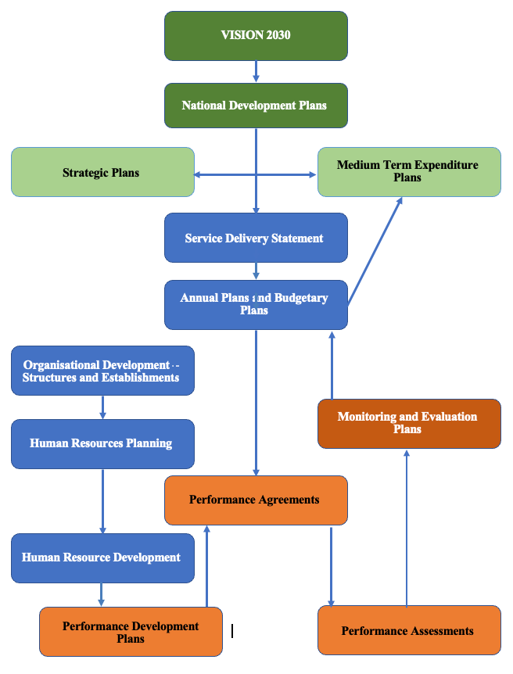

Performance management system

Customer Service Charters

Prepare Strategic and Annual Plans (Cont.)
Prepare OMA Annual Plans
For help preparing Annual Plans see the Public Performance Management Guidelines (PMG) (PDF_NPMS3_Section 5_Pg.32)., which contains information to assist OMAs in developing annual plans for relevant unit areas or an annual plan for the whole of an institution. This can also be guided by the:
- Commonwealth Secretariat - Strategic Management and Accountability for Results Toolkit SMART (PDF_NPMS6)
This provides specific tools to assist OMA in undertaking annual planning processes to ensure minimum mandatory requirements are met, include
  - an outline of a generic strategic planning process
  - the Commitment for Results (CFR) methodology, currently adopted by the OPM.
  - minimum requirements checklist.

Performance management system

Customer Service Charters

Prepare Service Delivery Statements
Service Delivery Statements (SDS) will be prepared by a high-level committee lead by the OPM, whilst working collaboration with both POBs and OMAs executives. The primary aim of the SDS is to present performance information on how the OMAs delivers services efficiently and effectively in achieving desired service delivery outcomes. The SDS forms the major portion of the relevant POBs Performance Agreement and the objectives of the OMA Annual Plan. It also allows the POB and the Government to assess performance and make informed policy decisions.
OMA identifies their material services (services), which are grouped into relevant service areas. Service standards (efficiency and effectiveness measures) and targets are presented for each service area and service. OMAs report estimated actual results against the service standards published in the prior year’s SDS. For help with preparing non-financial performance information contained in SDS Performance Statements see the Performance Management Guidelines (PDF_NPMS3_Section 4_Pg.25)
Information to assist OMAs in developing, reviewing, and improving information presented in SDS documents, including:
- background information providing context around the SDS
- specific guidance related to each element of SDS performance statements
- machinery-of-government issues, at the following:
  - Performance Management Guidelines-Annexure 1 Developing Performance Information (PDF_NPMS3_Ax1_Pg.55)
  - Commonwealth Secretariat_ SMART User Manual (PDF_NPMS5) and
  - Commonwealth Secretariat_ Strategic Management and Accountability for Results Toolkit (PDF_NPMS6)

Performance management system

Customer Service Charters

Performance Agreement (PA) and Personal Development Plan (PDP)
Performance agreements are an annual contract that provides a useful vehicle to bring results-oriented performance information into the POB, ED, and Staff’s performance evaluation. The Performance Agreements play an important role in determining executive performance ratings and remuneration and rewards. The procedure and guidelines to create a POB, Executive Director, and staff’s PA and Personal Development Plan (PDP) is detailed below. Staff members are required to continually improve all aspects of their performance under the Public Service Act, (Act 13 of 1995) and the PA is the principal vehicle used to manage and monitor this improvement.

Schedule regular conversations and help your employee meet and exceed their performance and development goals as part of your positive management practices.

Political Office Bearer (POB) performance agreement. <dropdown>

Executive Director performance agreement. <dropdown>

Staff’s performance agreement. <dropdown>

Performance management system

Business Process Management

Customer Service Charters

Performance Agreements (Cont.) – Political Office Bearers (POB)
Use the performance agreement template Performance Management Guidelines (PDF_NPMS3_Section 5.3_Performance Agreements and Personal Development Plans. Pg.43 to 45) to have a guided and effective conversation about performance, learning and career development.

Complete a PA shortly after the POB as per the POB’s contract. Record development priorities and the steps the executive will take to achieve them. See Leadership competencies from NIPAM for help.

The POB should base their PA on their Service Delivery Statement, and their Executive Director’s PA should align to theirs. Executive Directors should understand how their performance goals contribute to the work of the department and the sector. The POBs PA must be endorsed by the Secretary to Cabinet Director General and approved by the President or their delegate.

Key dates - 28 February
POBs must complete their end-of-year self-assessment and submit for approval before 31 March. Secretary of Cabinet must approve the POBs end-of-year self-assessment by 30 April.

Key dates - 30 April
Staff members must complete a new performance and development agreement and submit for approval before 30 April. The Office of the President approves the POBs performance agreement by 31 May.

Key dates - 31 August
POBs must complete their mid-year self-assessment and submit for approval by 30 September.

Key dates - 31 September
Secretary to the Cabinet must approve POB and ED mid-year self-assessment by 31 September.

Performance management system

Customer Service Charters

Performance Agreements (Cont.) – Executive Directors
Use the Executive Director performance agreement template Performance Management Guidelines (PDF_NPMS3_Section 5.3. Performance Agreements and Personal Development Plans. Pg.46 to 47) to set performance objectives that will deliver on government priorities and support learning goals.

Complete this within 3 months of commencing, as per the executive director’s contract, and then by the end of March each year. Record the steps the Executive Directors will take to achieve each objective and how it will deliver on government priorities. See the POBs SDS. Once the Executive Director drafts their Agreement, the OPM, Office of President provide feedback to the executive director on their draft agreement. They should seek input and approval from their POB (Minister) and submit their Agreement for final approval to the Secretary of the Cabinet or Delegate.

Key dates - 31 March
Executive Directors provide a self-assessment and seek comments and feedback from their POB (Minister) in March of each year.

Key dates - 30 April
Executives Directors are required to complete their agreement by the end of April of each year or within three months of commencing in their role (if they are newly appointed to the role during the financial year). OPM and the Office of the President provide feedback to Executive Directors on their draft agreements. Executives Directors discuss, seek input and approval of the agreement from their POB.
The agreement and self-assessment are submitted by OPM to the Secretary of the Cabinet, as the Presidents, for approval.

Key dates - 30 August
Executive Directors complete their mid-year self-assessment and seek feedback from their POB (Minister) in September of each year. The POB approves the mid-year review which is provided to the OPM for noting.

Performance management system

Customer Service Charters

Performance Agreements (Cont.) – Staff
Use the Performance Management Guidelines (PDF_NPMS3_Section 5.3. Performance Agreements and Personal Development Plans. Pg.48 to 49) to have a guided and effective conversation about performance, learning and career development. Complete a PA shortly after a new Staff member commences. Record initial performance expectations and review the document regularly to assess the employee's progress. Record development plans and career goals. Make sure that the employee’s goals support your OMA’s strategic plan and objectives. Include the steps the employee needs to take and the support you need to provide. See SMART performance goals for reference at:
  - Performance Management Guidelines-Annexure 1 Developing Performance Information (PDF_NPMS3_Ax1_Pg.55) and
  - Commonwealth Secretariat_ SMART User Manual (PDF_NPMS5)
  - Commonwealth Secretariat_ Strategic Management and Accountability for Results Toolkit (PDF_NPMS6)

Key dates - 30 March
Staff members provide a self-assessment and seek comments and feedback from their Supervisor in March of each year.

Key dates - 30 April
Staff members are required to complete their agreement by the end of April of each year or within three months of commencing in their role (if they are newly appointed to the role during the financial year). Staff members seek input and approval of the agreement from their Supervisor. The agreement and self-assessment are submitted by your Supervisor to the Supervisors Manager for approval.

Key dates - 30 August
Staff members complete their mid-year self-assessment and seek feedback from their Supervisor in September of each year. The Supervisor approved mid-year review is provided to the OPM for noting.

Performance management system

Customer Service Charters

Customer Service Charter
The Customer Service Charter was created as the system to manage service delivery between the government and citizens for goods and services. It defines the required quantity and quality of service delivery of the government. While at the same time it informs citizens of the nature and quality of the goods and services provided or on offer.

The Customer Service Charter is a significant milestone in the Public Services. This ensures citizens are informed about Government operations and services, as well as empowered to influence the quality of service at all levels. The Customer Service Charter provides citizens with a clear statement of the level of service they can expect. It includes a framework that facilitates the measuring and improvement of the quality of goods and services provided. This also includes transparent report to both government and citizens.

Namibia is a rapidly changing country, with an increasingly complex and diverse citizenship. This has resulted in growing citizen expectations. The Customer Service Charters allow Government to better meet these changing demands and become more flexible and responsive to the needs of our citizens.

For help with preparing a CSC see the Customer Service Charter Framework (PDF_NPMS7).

Performance management system

Customer Service Charters

Customer Service Charter (CSC) Checklist
The purpose of this Audit Checklist form is to establish consistent level of CSC Implementation in OMAs and Regional Councils.
The CSC Framework is divided into three areas/parts being:
• Development (Institutionalisation) of CSC– Part I.
• Implementation (Internalisation) of CSC – Part II and.
• Sustainability (Living the Charter) – Part III.

An OMA and RC will be audited in these areas to establish at which level they have implemented CSC Initiative and also to determine the required interventions from OPM to support them to fully implement the challenging initiative.
The audit scores are weighing 100% points in total of all three parts of CSC Framework. For help with preparing a CSC audit see the Customer Service Charter Checklist (PDF_NPMS8)

3 Refurbishing of Personnel Administration: Scaling New Heights, Tenth Report of Second Administrative Reforms Commission-2005 (Government of India, 2008)

